**Custom Mobile App Development Company in Noida**

RS Organisation is a **custom mobile app development company in Noida** offering innovative, scalable, and secure mobile solutions tailored to your business needs. Whether you're a startup or an enterprise, we specialize in delivering high-performance apps. As a trusted **mobile app development company in Noida**, we ensure seamless digital transformation with cutting-edge technologies that help your brand stand out in today’s competitive market.

**Mobile Application Development Services for Multiple Platforms**

**1. Android App Development**  
As a leading **android app development company in Noida**, we develop robust, intuitive, and secure Android apps tailored to user needs. Our experienced developers use Kotlin and Java to deliver scalable Android applications compatible with all Android devices. We follow Google's latest guidelines to ensure performance and usability, helping you connect with millions of Android users effectively.

**2. iOS App Development**  
We design high-performing iOS apps that align with Apple’s ecosystem. From concept to deployment, our iOS solutions offer top-notch user experiences. Our iOS development team leverages Swift and Objective-C to build sleek and responsive apps for iPhones and iPads, ensuring smooth functionality and maximum ROI for your business.

**3. Cross-Platform App Development**  
Reach a broader audience with our cross-platform app development services. We build mobile apps using Flutter and React Native, allowing you to maintain a single codebase for both Android and iOS. This cost-effective solution ensures faster development and seamless performance across platforms, helping you launch quicker and save on overhead.

**4. Enterprise Mobile App Development**  
We offer scalable mobile solutions tailored for enterprises. From CRM to workflow automation, our mobile applications enhance productivity and security. RS Organisation ensures your business processes go mobile with intuitive dashboards, real-time data syncing, and cloud integration, transforming your operations for the digital age.

**5. UI/UX Design Services**  
Great apps start with great design. Our expert UI/UX team focuses on user-friendly interfaces and visually engaging experiences. We follow best practices in usability and accessibility to ensure your app is not only beautiful but also functional and intuitive, creating a seamless experience across all devices and user demographics.

**6. App Maintenance & Support**  
Our work doesn't end with app deployment. We offer ongoing maintenance and support services to keep your app running smoothly. From bug fixes to version updates, RS Organisation ensures your app remains secure, up-to-date, and relevant in a rapidly evolving digital landscape.

**Trending Custom App Development Stack We Use**

**1. Blockchain**  
We integrate **blockchain** technology to develop secure, decentralized mobile applications. From crypto wallets to smart contracts, we enable trustless systems for businesses that need transparency and data integrity.

**2. AR/VR**  
Augmented and Virtual Reality bring immersive experiences to life. We create interactive AR/VR applications that elevate user engagement, ideal for education, real estate, and gaming industries.

**3. Metaverse**  
Step into the future with metaverse app development. We help businesses build virtual environments where users can interact, shop, and collaborate in entirely new digital spaces.

**4. IoT (Internet of Things)**  
Our IoT-powered apps connect smart devices seamlessly. Whether it's wearables or industrial sensors, we build apps that track, analyze, and control data in real-time.

App Development **Technologies We Work-m On iss link ka copy karna h**

<https://www.imgglobalinfotech.com/mobile-app-development.php>

**Mobile App Development Workflow**

**1. Requirement Analysis**  
Our journey begins with understanding your needs. We conduct detailed requirement analysis, competitor research, and market validation to ensure your idea is viable and aligned with user expectations. This step forms the foundation for a successful app.

**2. UI/UX Designing**  
Next, we bring your vision to life through engaging UI/UX designs. Our design process involves wireframing, prototyping, and usability testing to ensure the final product is intuitive, user-friendly, and visually appealing across all devices.

**3. App Development**  
Using agile methodology, our developers begin coding the app. We ensure modular, scalable, and secure architecture. We use modern frameworks and tech stacks suitable for both native and cross-platform apps to deliver robust performance.

**4. Quality Assurance**  
Before launch, every app goes through rigorous QA testing. We test for functionality, usability, security, and device compatibility. Our team ensures your app is bug-free, stable, and provides a smooth user experience under all scenarios.

**5. Deployment**  
Once approved, the app is deployed to app stores. Our deployment team ensures smooth publishing, handling permissions, metadata, and optimization. We follow all app store guidelines for quick and efficient go-live.

**6. Support & Maintenance**  
post-launch, we offer complete support and maintenance. We monitor performance, address user feedback, and roll out timely updates to keep your app competitive and compatible with the latest technologies.

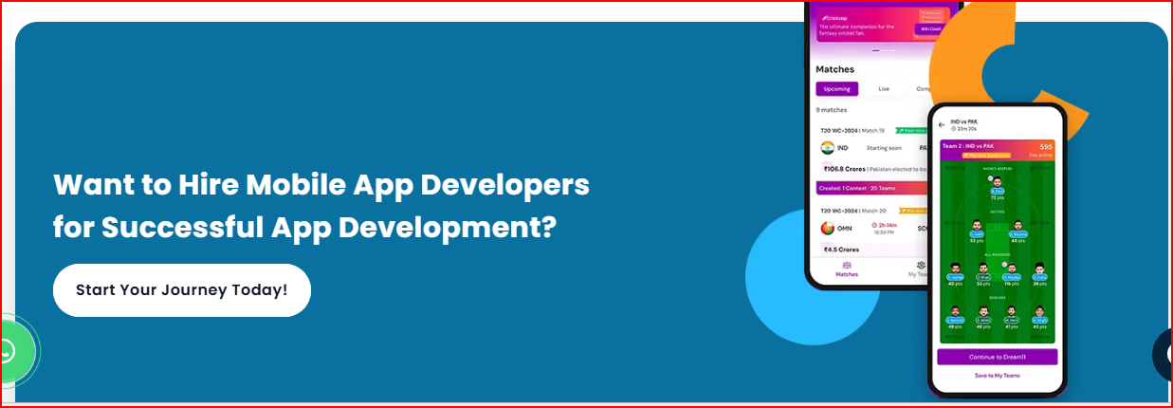

**Why Choose RS Organisation for Mobile App Development Services?**

RS Organisation stands out as a top **mobile app development company in Noida** due to its client-centric approach and industry expertise. Our team combines creativity with technology to build powerful apps that solve real business problems. We emphasize transparency, timely delivery, and scalable architectures to help our clients achieve long-term success. Whether you need enterprise-grade apps or MVPs, we deliver results that drive growth.

Industries we services

Google review